換發外國法事務律師執業許可證申請書
Application for the Renewal of Foreign Legal Affairs Attorney’s Practice Permit
中文姓名  Chinese name |  | 英文姓名  English name |  | 請黏貼２吋照片  Please affix one  2-inch photo
出生日期  Date of Birth |  | 身分證明  文件編號  ID Number
國 籍
Nationality
電子郵件
Email
在台住所
Residence in Taiwan
執業型態  Type of Practice | □ 獨資 Sole proprietorship □ 合署Co-location  □ 受僱Employed (受僱於employed by )  □ 合夥Partnership (與in partnership with )  ＊Please notice ”Regulations Governing the Permission for Foreign Attorneys to Employ ROC Attorneys or to Partner with ROC Attorneys to Operate a Foreign Law Firm”
事務所  名稱及地址  Name & Address of the Law Firm | 事務所名稱Name of the Law Firm:  地址Address:
原資格國名(或地區)Country Name of “Home Jurisdiction”(or Region)
原外國法事務律師執業許可證號The original Foreign Legal Affairs Attorney’s Practice Permit number
取件方式Delivery method
□自取，請填寫聯絡電話Pick up in person, please fill in the contact phone number：
□請掛號郵寄，請填寄送地址Send by registered mail, please fill in the delivery address：
Appendix
- □2-inch recent photo (Affix to the application form)
(1)A color photo taken within the last six months (height: 4.5 cm, width: 3.5 cm, excluding border) that are front facing and hat off, with clear facial features and monochrome background on glossy paper (except for visually impaired persons, but do not wear color glasses), and avoid using photos taken with color contact lens, or color pupil enlargement lens.
(2) Send electronic file to mojlawyer@mail.moj.gov.tw
2. □For ROC nationals, please submit a front-and-back copy of the national ID card;
For non-ROC nationals, please submit a copy of your passport.
3. □Proof of valid home jurisdiction attorney qualifications, and proof of never receipt of disciplinary action.
If it is not in Chinese, please submit a copy of Chinese translation.
4. □The original Practice Permit issued by the Ministry of Justice
Must be returned for cancellation.
Fee Payable - NT$1,500
1.□ Postal Money Order (please purchase a money order at the post office and specify in the title thereof that it is payable to "法務部")
2.□ Cash (please pay the fee at the Ministry of Justice at Rm.111, 1F., No.130, Sec. 1, Chongqing S. Rd., Zhongzheng Dist., Taipei City)
3.□ e-Bill National Payment Website (please visit "e-Bill National Payment Website (e-Bill全國繳費網)" - "Government Authority-Related Fees (政府機關相關費用)" - "Payment of Fees to National Treasury (國庫款項費用)" to make a payment)
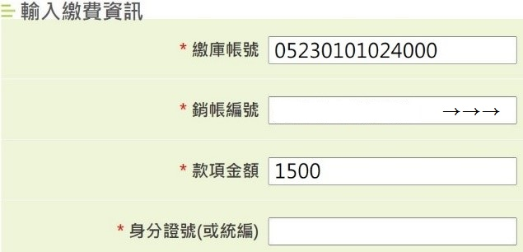
- ” Please fill “05230101024000” in “Payee Account Number” (繳庫帳號).
- Please fill 12345678 + your Foreign Legal Affairs Attorney’s Practice Permit nember（FPL****）in “Debit Account Number” (銷帳編號) in a total of 12 digits
For example, “No.110FPL-0001”, please fill in
：123456780001

The wire transfer should be made with your own ATM card, and the application form should be delivered to us on the day of the wire transfer or the immediately following day for our verification.
Date of e-Bill Wire Transfer (required):
Application Date：
Phone Number：_________________________Applicant Signature：________________________

具我國國籍者，請填身分證字號；未具我國國籍者，請填護照號碼或居留證號 Passport Number or National ID Card Number

